CA659 Mathematical Models/Computational Science
In-Class Exercise 4
AutoCorrelelograms
Exercise to fit a model to LA Heart Attack Data time series
- First download the cmort data from loop into the R working directory and then need to do: mort=scan("cmort.dat")
- Plot the data using the plot() function
- Convert the data to a time series object using mort=ts(mort) (may need to use do library(stats)for this).
- Decide whether the series stationary is stationary or not using the ADF.test(mort) function in the notes (hint: don’t forget to call library(tseries)
- If it isn’t stationary you can try taking first differences to do this you will need the function diff(mort,1)
- Next, you should check the ADF of the differenced series to check that it is stationary.
- Using PACF, estimate the order of the autoregressive model (p) that can be used to approximate the series

What do the following AutoCorrelation Functions Depict?

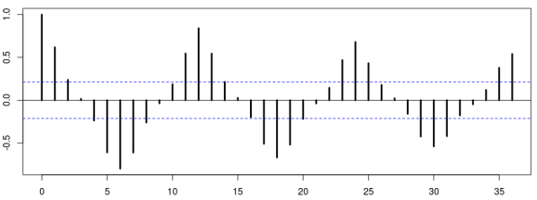

Answer: Annual Seasonal Pattern

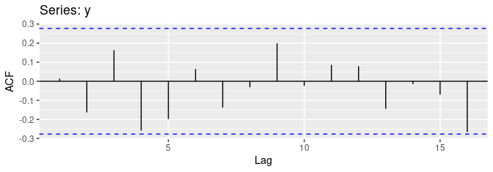
Answer: Random noise

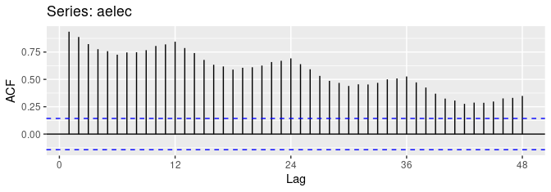
Answer: Seasonal pattern + trend
- What do you think the ACF of a Cyclical Time series would resemble?
Answer: When the pattern in a time series is cyclical, the ACF will peak around the average cycle length.

